Mata Kuliah | : | Pemrograman Web Lanjut (PWL)
Program Studi | : | D4 – Teknik Informatika
Semester | : | 4
Kelas | : | TI 2A
NIM | : | 244107020240
Nama | : | Mochammad Rijal Dzaki Rifki Afifudin
Jobsheet Ke- | : | 2

Laporan Jobsheet

- Praktikum ke-1
Langkah | Jawaban/Deskripsi
1 | Kode program:  Route::get('/hello', function () {  return 'Hello World';  });  Hasil:  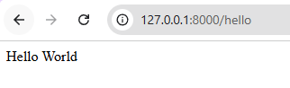
2 | Kode program:  Route::get('/world', function () {  return 'World';  });  Hasil:  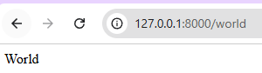
3 | Kode program:  Route::get('/', function () {  return 'Selamat Datang';  });  Route::get('/about', function () {  return 'NIM : 244107020240, Nama : Mochammad Rijal Dzaki Rifki Aifudin' ;  });  Hasil:  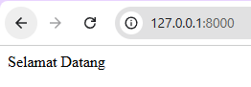  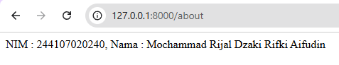
4 | Kode program:  Route::get('/user/{name}', function ($name) {  return 'Nama saya '.$name;  });  Hasil:  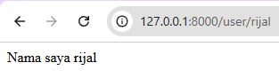  Jika tanpa menggunakan nama, maka akan muncul halaman “NOT FOUND”  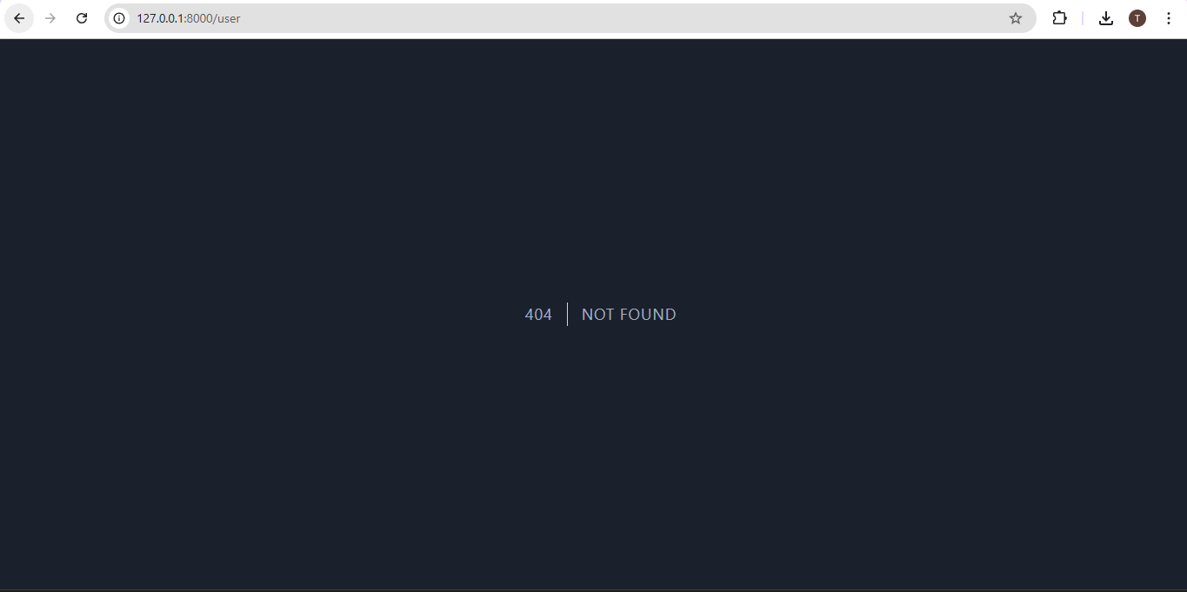
5 | Kode program:  Route::get('/posts/{post}/comments/{comment}', function ($postId, $commentId) {  return 'Pos ke-'.$postId." Komentar ke-: ".$commentId;  });  Hasil:  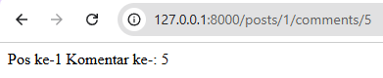
6 | Kode program:  Route::get('/articles/{id}', function ($id) {  return 'Halaman Artikel dengan ID :'.$id;  });  Hasil:  
7 | Kode program:  Route::get('/user/{name?}', function ($name=null) {  return 'Nama saya '.$name;  });  Hasil:  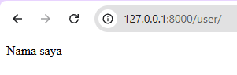  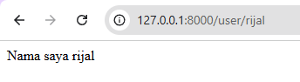  Hasilnya ketika tidak mengetikan nama, maka akan menampilkan “Nama saya”, hal ini berbeda dengan sebelumnya yang dimana jika tanpa mengetikan nama, makan akan menampilkan halaman “NOT FOUND”
8 | Kode program:  Route::get('/user/{name?}', function ($name='John') {  return 'Nama saya '.$name;  });  Hasil:  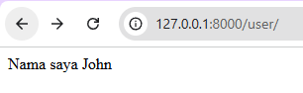  Variable nama telah disetel dengan “John” jika pada url tidak mengketikan nama, maka akan menampilkan John sebagai default

- Praktikum ke-2
Langkah | Jawaban/Deskripsi
1 | Kode program:  Controller:  public function hello() {  return 'Hello World';  }  Routes:  Route::get('/hello', [WelcomeController::class,'hello']);  Hasil:  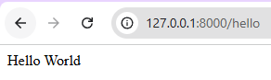
2 | Kode program:  Controller:  public function index(){  return 'Selamat Datang';  }  public function about(){  return 'Nama : Mochammad Rijal Dzaki Rifki Afifudin, NIM : 244107020240';  }  public function articles($id){  return 'Halaman Artikel dengan id '.$id;  }  Routes:  Route::get('/', [PageController::class,'index']);  Route::get('/about', [PageController::class,'about']);  Route::get('/articles/{id}', [PageController::class,'articles']);  Hasil:  Index:  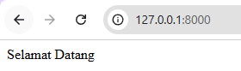  About:  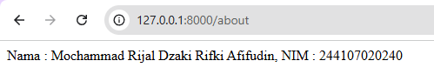  Articles:  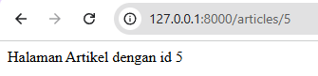
3 | Kode program:  Controller:  public function index()  {  return 'Halamann daftar foto';  }  public function create()  {  return 'Halamann form tambah foto';  }  public function store(Request $request)  {  return 'Proses simpan foto baru';  }  public function show(string $id)  {  return 'Menampilkan foto dengan id '. $id;  }  public function edit(string $id)  {  return 'Halaman form edit foto dengan id '.$id;  }  public function update(Request $request, string $id)  {  return 'Proses update foto dengan id '.$id;  }  public function destroy(string $id)  {  return 'Proses hapus foto dengan id '.$id;  }  Route:  Route::resource('photos', PhotoController::class);  Hasil:  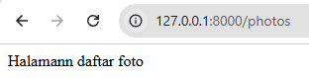  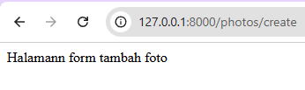  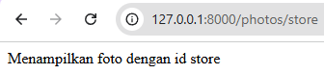  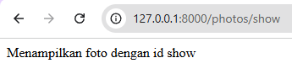  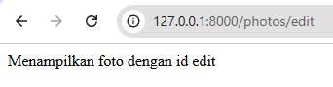  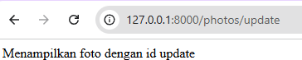  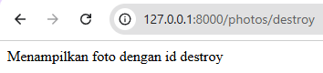

- Praktikum ke-3
Langkah | Jawaban/Deskripsi
1 | Kode program:  Hello.blade.php:  <!DOCTYPE html>  <html lang="en">  <head>  <meta charset="UTF-8">  <meta name="viewport" content="width=device-width, initial-scale=1.0">  <title>Document</title>  </head>  <body>  <h1>Hello, {{ $name }}</h1>  </body>  </html>  Route:  Route::get('/greeting', function (){  return view('hello', ['name' => 'Andi']);  });  Hasil:  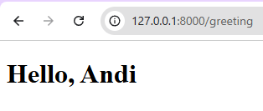
2 | Membuat folder baru bernama blog di folder view:  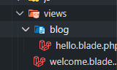  Route:  Route::get('/greeting', function (){  return view('blog.hello', ['name' => 'Andi']);  });  Hasil:  Hasilnya sama seperti percobaan sebelumnya
3 | Kode program:  Controller:  public function greeting(){  return view('blog.hello', ['name' => 'Andi']);  }  Route:  Route::get('/greeting', [WelcomeController::class,'greeting']);  Hasil:  Hasilnya sama dengan percobaan sebelumnya
4 | Kode program:  Controller:  public function greeting(){  return view('blog.hello')  ->with('name','Andi')  ->with('occupation','Astronaut');  }  Hello.blade.php:  <!DOCTYPE html>  <html lang="en">  <head>  <meta charset="UTF-8">  <meta name="viewport" content="width=device-width, initial-scale=1.0">  <title>Document</title>  </head>  <body>  <h1>Hello, {{ $name }}</h1>  <h1>You are, {{ $occupation }}</h1>  </body>  </html>  Hasil:  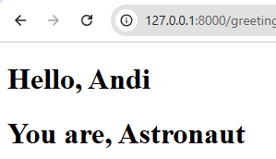

- Soal Praktikum
Langkah | Jawaban/Deskripsi
1 | Membuat project baru dengan nama ‘POS’  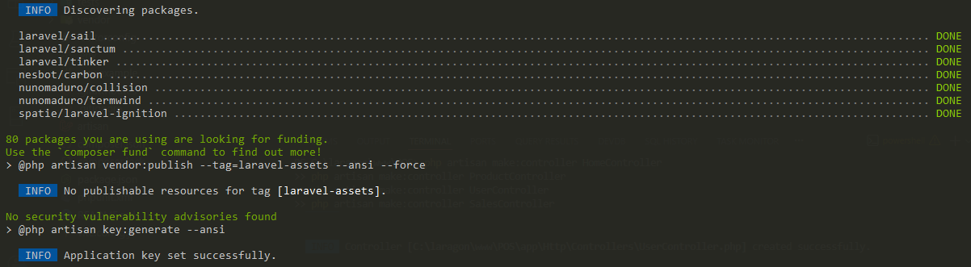
2 | Membuat controller:  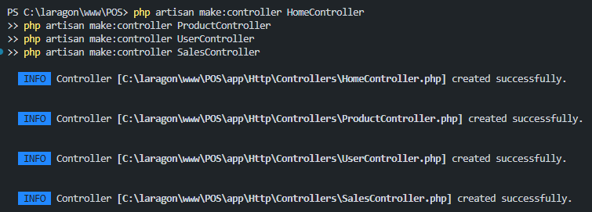
3 | Setting route:  <?php  use Illuminate\Support\Facades\Route;  use App\Http\Controllers\HomeController;  use App\Http\Controllers\ProductController;  use App\Http\Controllers\UserController;  use App\Http\Controllers\SalesController;  // 1. Halaman Home  Route::get('/', [HomeController::class, 'index']);  // 2. Halaman Products  Route::prefix('category')->group(function () {  Route::get('/food-beverage', [ProductController::class, 'foodBeverage']);  Route::get('/beauty-health', [ProductController::class, 'beautyHealth']);  Route::get('/home-care', [ProductController::class, 'homeCare']);  Route::get('/baby-kid', [ProductController::class, 'babyKid']);  });  // 3. Halaman User  Route::get('/user/{id}/name/{name}', [UserController::class, 'profile']);  // 4. Halaman Penjualan  Route::get('/sales', [SalesController::class, 'index']);
4 | Setting Controller  HomeController:  <?php  namespace App\Http\Controllers;  use Illuminate\Http\Request;  class HomeController extends Controller  {  public function index() {  return view('home');  }  }  ProductController:  <?php  namespace App\Http\Controllers;  use Illuminate\Http\Request;  class ProductController extends Controller  {  public function foodBeverage() {  return view('products.food-beverage');  }  public function beautyHealth() {  return view('products.beauty-health');  }  public function homeCare() {  return view('products.home-care');  }  public function babyKid() {  return view('products.baby-kid');  }  }  SalesController:  <?php  namespace App\Http\Controllers;  use Illuminate\Http\Request;  class SalesController extends Controller  {  public function index() {  return view('sales.index');  }  }  UserController:  <?php  namespace App\Http\Controllers;  use Illuminate\Http\Request;  class UserController extends Controller  {  public function profile($id, $name) {  return view('user.profile', compact('id', 'name'));  }  }
5 | Setting resources  Membuat file yang bernama:  home.blade.php:  <!DOCTYPE html>  <html lang="en">  <head>  <meta charset="UTF-8">  <meta name="viewport" content="width=device-width, initial-scale=1.0">  <title>Point Of Sales</title>  </head>  <body>  <h1>Selamat Datang di Aplikasi POS</h1>  <p>Ini adalah halaman awal website.</p>  </body>  </html>  Berikutnya membuat folder yang bernama Product, User & Sales  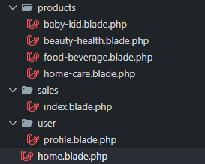  berikutnya membuat file dalam folder product yang bernama :  baby-kid.blade.php:  <!DOCTYPE html>  <html lang="en">  <head>  <meta charset="UTF-8">  <meta name="viewport" content="width=device-width, initial-scale=1.0">  <title>Baby Kid</title>  </head>  <body>  <h1>Daftar Produk: Baby Kid</h1>  </body>  </html>  beauty-health.blade.php:  <!DOCTYPE html>  <html lang="en">  <head>  <meta charset="UTF-8">  <meta name="viewport" content="width=device-width, initial-scale=1.0">  <title>Beauty Health</title>  </head>  <body>  <h1>Daftar Produk: Beauty Health</h1>  </body>  </html>  food-beverage.blade.php:  <!DOCTYPE html>  <html lang="en">  <head>  <meta charset="UTF-8">  <meta name="viewport" content="width=device-width, initial-scale=1.0">  <title>Food Beverage</title>  </head>  <body>  <h1>Daftar Produk: Food & Beverage</h1>  </body>  </html>  home-care.blade.php:  <!DOCTYPE html>  <html lang="en">  <head>  <meta charset="UTF-8">  <meta name="viewport" content="width=device-width, initial-scale=1.0">  <title>Home Care</title>  </head>  <body>  <h1>Daftar Produk: Home Care</h1>  </body>  </html>  Berikutnya membuat file baru pada folder user yang bernama:  profile.blade.php:  <!DOCTYPE html>  <html lang="en">  <head>  <meta charset="UTF-8">  <meta name="viewport" content="width=device-width, initial-scale=1.0">  <title>Profile</title>  </head>  <body>  <h1>Profil Pengguna</h1>  <p>ID User: {{ $id }}</p>  <p>Nama User: {{ $name }}</p>  </body>  </html>  Berikutnya membuat file baru pada folder sales yang bernama:  index.blade.php:  <!DOCTYPE html>  <html lang="en">  <head>  <meta charset="UTF-8">  <meta name="viewport" content="width=device-width, initial-scale=1.0">  <title>Sales</title>  </head>  <body>  <h1>Halaman Transaksi POS</h1>  </body>  </html>
6 | Hasil  Halaman home:    Halaman user:  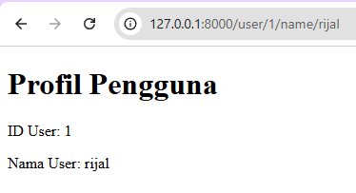  Halaman food-beverage:    Halaman beauty-health:    Halaman home-care:  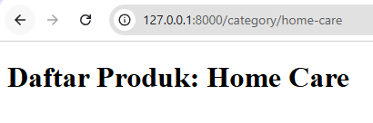  Halaman baby-kid:    Halaman sales:  

